3. Introduction
Disaster management communication is a critical component in reducing the impact of natural and man-made emergencies such as floods, cyclones, earthquakes, fires, and road accidents. Timely and effective communication enables citizens to take preventive actions, avoid high-risk areas, and respond appropriately during crises. In rapidly growing urban regions, especially densely populated cities, the need for clear and reliable communication becomes even more important due to the high risk of infrastructure disruption and large-scale impact on human life.
Existing disaster communication systems rely on multiple channels such as government SMS alerts, mobile notifications, television broadcasts, radio, and social media platforms. In India, agencies like NDMA and IMD issue warnings through SMS and official platforms, while international systems such as FEMA Wireless Emergency Alerts provide geo-targeted notifications. Although these systems are effective in delivering alerts quickly, they primarily focus on broadcasting information rather than ensuring that the message is understandable, accessible, and actionable for all users. Alerts are often complex, issued in a single language, and lack clear instructions, which can lead to confusion, delayed response, and increased risk during emergencies.
Another major challenge is the rise of misinformation and inconsistent messaging across different platforms. Social media, while enabling rapid information sharing, often spreads unverified or exaggerated content, creating panic and misguiding citizens. Additionally, current systems operate as one-way communication channels, where authorities cannot measure whether the public has understood the message. This lack of feedback prevents continuous improvement in communication strategies during ongoing disasters.
To address these challenges, there is a need for an intelligent and inclusive disaster communication system that goes beyond simple information dissemination. The proposed solution focuses on delivering structured, multilingual, and action-oriented alerts, supported by accessibility features and real-time feedback mechanisms. By integrating modern technologies such as AI-based processing, location-based filtering, and interactive communication tools, the system aims to enhance clarity, improve public understanding, and enable faster and more effective response during emergencies.

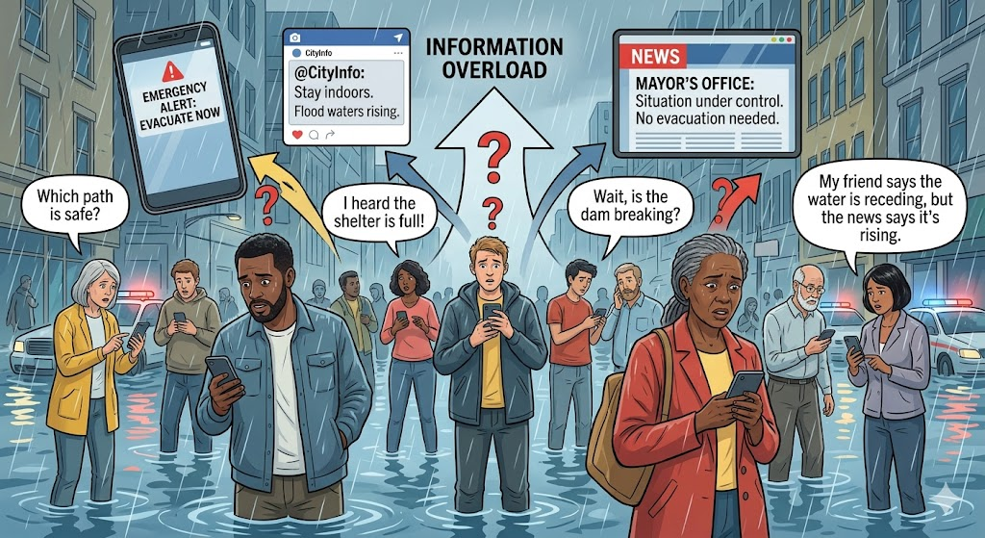
Figure 3.1

- Disaster Communication Problem Scenario
This figure 3.1 illustrates a typical disaster situation where citizens are exposed to multiple sources of information such as mobile alerts, social media updates, and news broadcasts simultaneously. Due to the lack of coordination among these sources, the information received is often inconsistent, unverified, or incomplete. This leads to confusion among the public, making it difficult for individuals to decide what actions to take. In such situations, misinformation can spread rapidly, increasing panic and anxiety. People may either overreact or ignore critical warnings due to lack of trust. The figure highlights how fragmented communication systems fail to provide clear guidance during emergencies. It emphasizes the importance of having a centralized platform that ensures consistency and reliability of information. Overall, it demonstrates the real-world communication challenges faced during disaster scenarios.

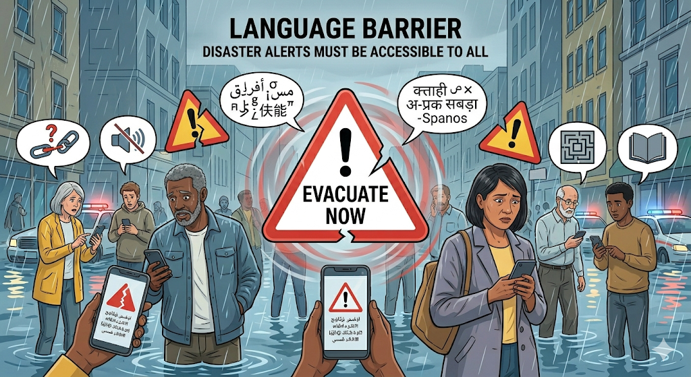
Figure 3.2

- Communication Gap and Language Barrier
This figure 3.2 represents the communication gap that arises due to language barriers in disaster alert systems. In many regions, alerts are issued in a single dominant language, which may not be understood by all sections of the population. Migrant workers, elderly individuals, and people with limited literacy may find it difficult to interpret such messages. As a result, even though alerts are delivered on time, their effectiveness is reduced because users cannot fully understand the content. This can delay response actions and increase vulnerability during emergencies. The figure highlights the importance of multilingual communication in ensuring inclusivity and accessibility. It also reflects the need for simplified and user-friendly messaging formats. Addressing language barriers is essential for improving public safety and ensuring that critical information reaches everyone effectively.

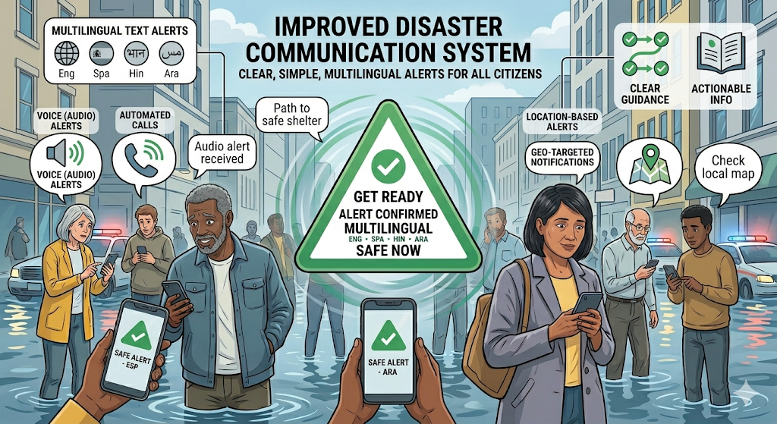
Figure 3.3

- Improved Disaster Communication System Concept
This figure 3.3 illustrates the concept of an improved disaster communication system that focuses on clarity, accessibility, and user understanding. In this approach, alerts are delivered in multiple languages and presented in a simple, structured format that is easy to understand. The inclusion of audio support ensures that even visually impaired or low-literacy users can access the information. Additionally, alerts are tailored based on the user’s location, ensuring relevance and reducing unnecessary information. The system also emphasizes action-oriented messaging, guiding users on what steps to take during emergencies.
By providing clear and reliable information, it helps reduce confusion and panic among citizens. The figure demonstrates how integrating technology and user-centric design can significantly enhance disaster communication. Overall, it represents a more efficient and inclusive approach to emergency alert systems.

